Job talk for joint search between the
Department of History & Lyman Briggs College

DR. NAOKO WAKE
presents:
“The Bomb, Damaged Bodies, and the Opening of Memory in Asian America”
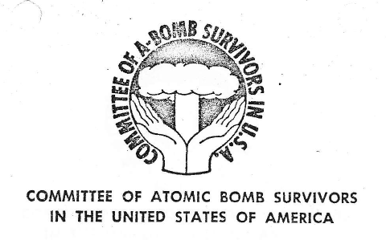

Naoko Wake is the author of Private Practices: Harry Stack Sullivan, the Science of Homosexuality, and American Liberalism (Rutgers UP, 2011). She is currently co-authoring a book, Hiroshima Nagasaki Beyond the Ocean, and conducting oral history research for a separate monograph, Trans-Pacific Memories of the Bomb: Gender, Family, and Generation.

340 Morrill Hall
4:10 pm, Thursday, April 5th
Light refreshments will be provided

